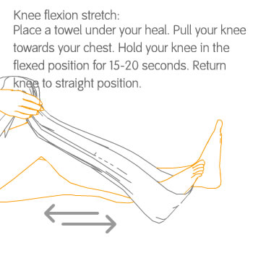

http://oxinium.co.uk/patients/knee_rehabilitation.php

